Daily Report
Date : 23.02.26
Task : Connect the front end to the backend web socket pathway. the frontend also should listen for back-end events and update the UI in real time without needing a page refresh
Today Working: Today I Have Worked On Integrated Socket.IO for real-time updates between frontend and backend. Implemented board-based rooms and added live events for task creation, updates, movement, comments, and assignments. Task Management System now supports multi-user real-time collaboration without page refresh.
• Installed and configured Socket.IO in the Node.js server.
• Replaced app.listen() with HTTP server setup.
• Attached Socket.IO instance to Express using app.set("io", io).
• Implemented board-based room joining using socket.join(boardId).
• Ensured only users inside a specific board receive real-time updates.
• Connected frontend using socket.io-client.
• Added real-time listeners in Board page.
• Ensured UI updates instantly without refresh.

Screenshots :
Web Socket :
Backend Connection:
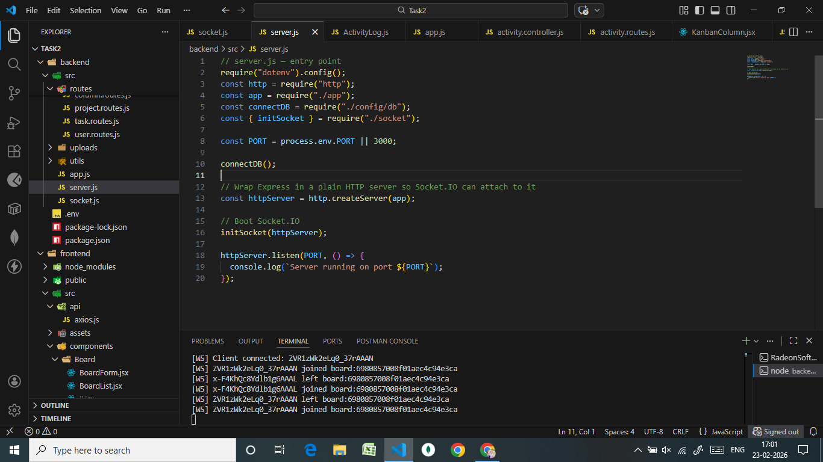

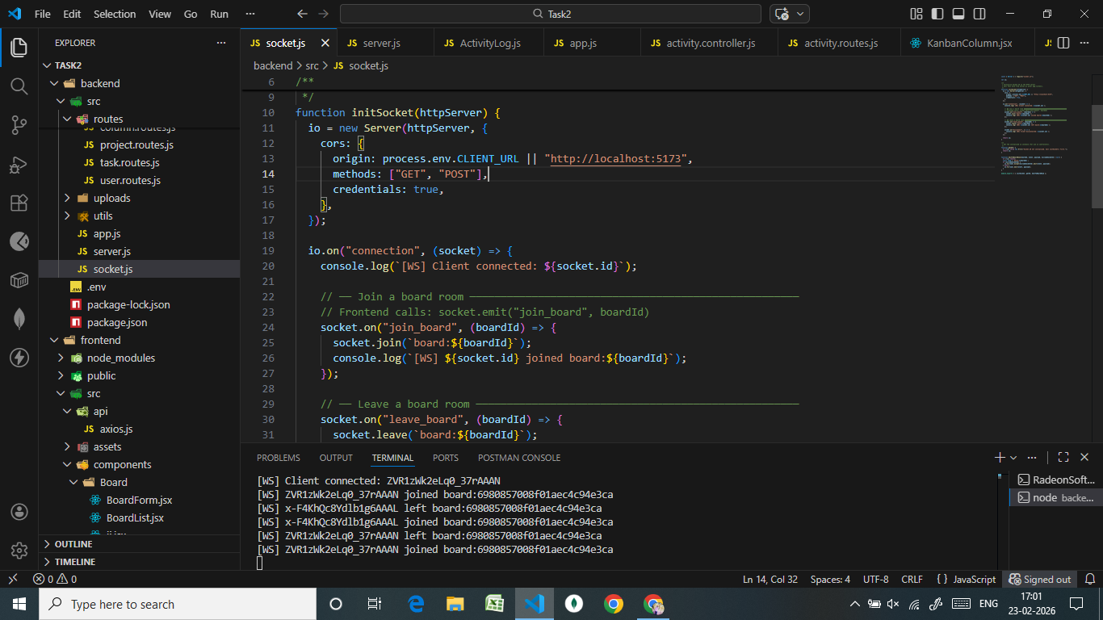

Frontend Connection:
